How to connect to the SETeam5 repository

1. After getting a github account, open the github application and login.
   1. Or create a github account straight from here.

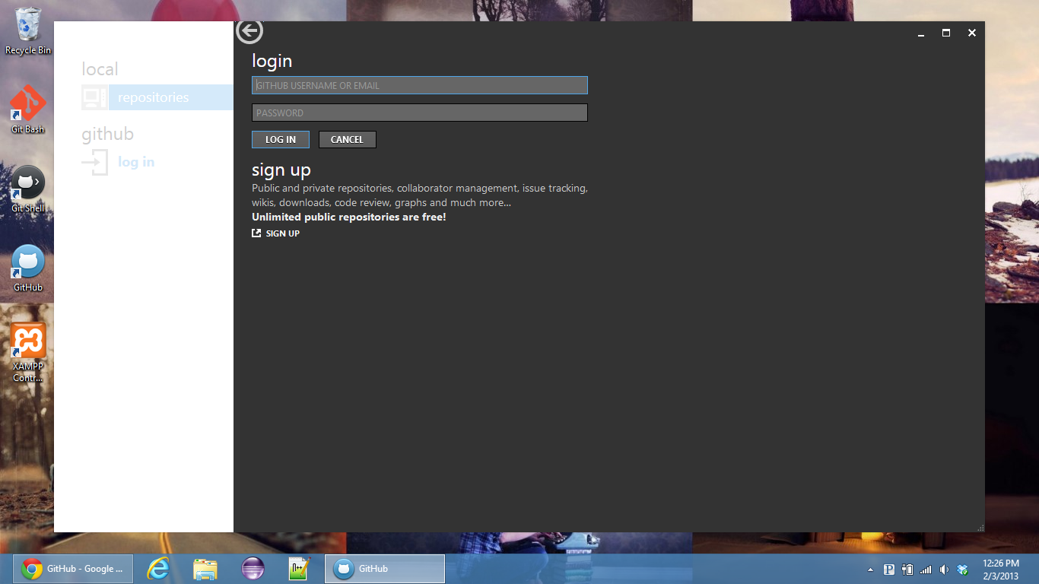

1. When logged in, selected your username from under the GitHub label. If you are added to the repository then the repo “polspeek/SETeam5” should appear. Clone the repo.
   1. When cloned, open the repo.

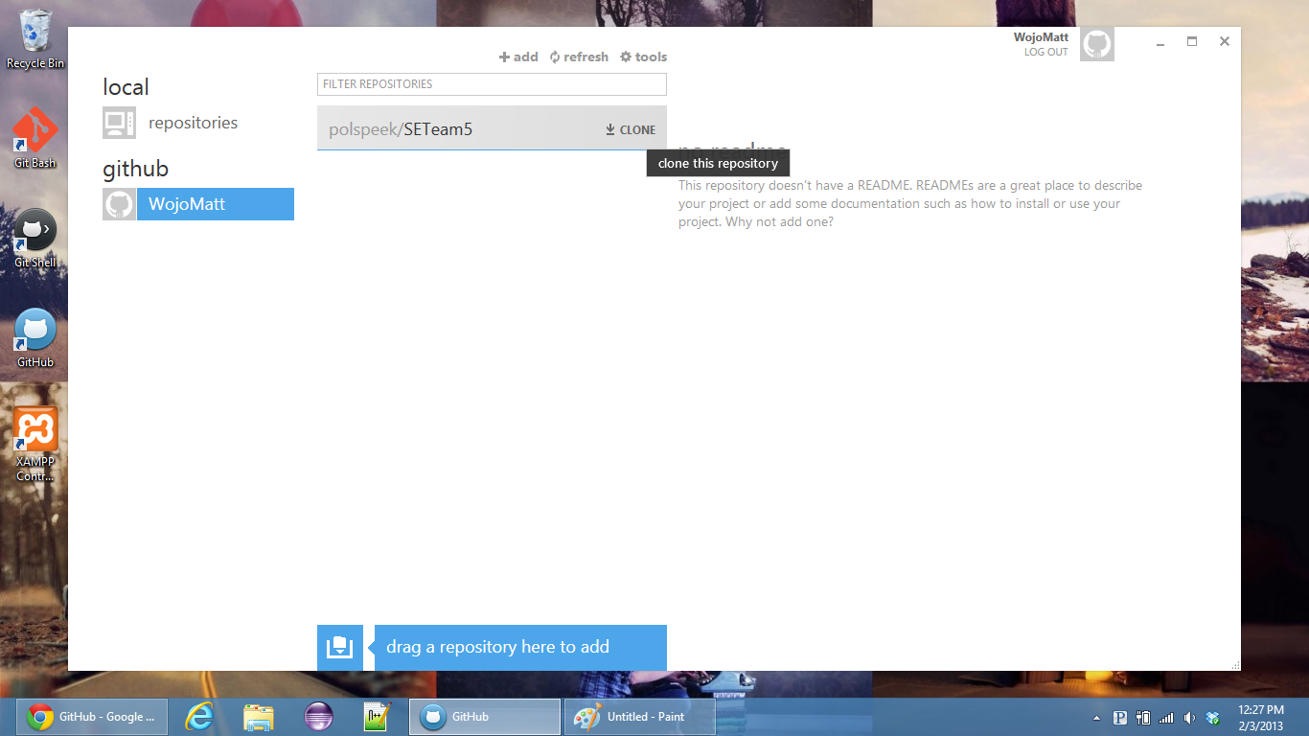

1. 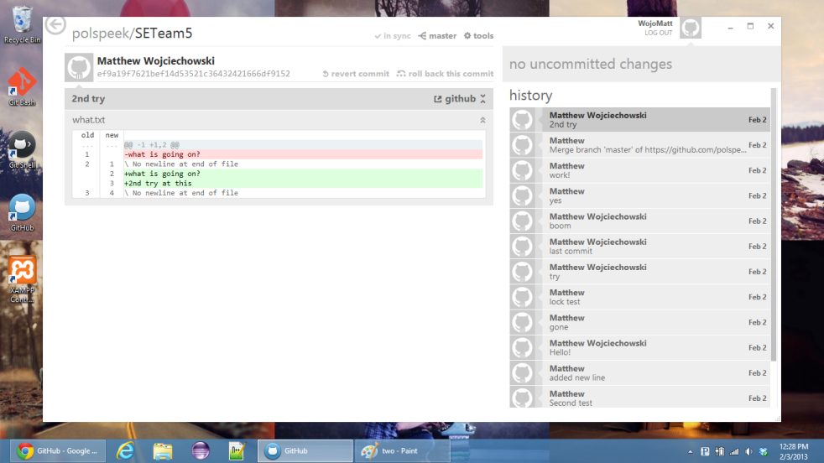Once the repo is opened, you should see all the history of the repo. Here you will be able to commit and sync your local repo so that everyone can see the changes.
2. This is an intro on how to get to the repo. The full tutorial on how to use it is forthcoming.